Zewail City of Science, Technology and Innovation University of Science and Technology
School of Computational Sciences and Artificial Intelligence
CSAI 203 - Fall 2025

Introduction to Software Engineering
All-in-one AI Project Management and DevOps Platform
Design Phase Document
Team Number: #21
Team Members:
Ahmed Mohsen Abdelsattar 202301138
Jana Ahmed Mohamed 202301800
Ali Bahaa Eldin Elrouby 202301680
Mazen Ahmed Galal 202300900
Hany Mohamed Abdulfattah 202302380

1. Introduction
1.1 Purpose of the Document
The purpose of this Design Phase Document (DPD) is to translate the comprehensive set of validated requirements outlined in the Software Requirements Specification (SRS) into a detailed, executable technical blueprint for the development of our AI Project Management system. This document acts as the foundational architecture, defines the technology stack, specifies internal and external interfaces, and details the data models necessary for implementation. It serves as the primary technical reference for the development and quality assurance teams, ensuring that the final system meets all functional and non-functional requirements (FRs and NFRs) specified in the SRS.
1.2 Scope of the Design Phase
- Architectural Design: Defining the structure, components, and communication patterns of the Service-Oriented Architecture (SOA).
- Component Specification: Making all the sequence diagrams and the system architecture diagrams to detail every functionality of the functional requirements.
- Data Design: Creation of the logical and physical data models for all domain databases.
- UI creation: Making wire frames to the whole design to imagine the project shape before coding it.
1.3 Intended Audience
- Software Architects and Leads: To validate the overall design approach and ensure compliance with industry best practices and organizational standards.
- Development Team: To serve as the definitive guide for coding, component integration, and also making testcases to test the project after finalizing it.
- Project Managers and Stakeholders: To understand the technical approach, resource dependencies, and critical design decisions underlying the implementation timeline.
1.4 Overview of the Contents
- Section 2: System Overview provides a high-level description of the system, its purpose, and outlines the primary design goals and constraints driving the architecture.
- Section 3: Architectural Design fully specifies the chosen Service-Oriented Architecture (SOA), including a visual System Architecture Diagram, a discussion of the architectural style and components, and the finalized Technology Stack and Tools.
- Section 4: Detailed Design is the core technical section, detailing the application of the Model-View-Controller (MVC) design pattern, presenting detailed UML Class and Sequence Diagrams, illustrating the proposed UI/UX via Wireframes/Mockups, and specifying the final Data Design, including the Database Schema/File Structure and Data Dictionary.
- Section 5: Conclusion provides a summary of the key design decisions and final output generated during this phase.
2. System Overview
2.1 Brief Description of the System
The AI Project Management System (AIPMS) is a next-generation, web-based platform designed to be an all-in-one project management and DevOps solution, merging the best features of platforms like Jira, ClickUp, and Azure DevOps. It functions as a central hub for project teams, facilitating collaboration, planning, progress tracking, and delivering AI-driven insights.
The core purpose of AIPMS is to simplify and enhance the entire project lifecycle (planning, execution, monitoring, and delivery) by using artificial intelligence to analyze data, predict risks, and provide actionable insights.
Key functionalities include:
- AI-driven automation: Features like predicting task delays, automatic sprint planning, emotion-based workload balancing, and AI-generated reports.
- Core Project Management: Creating and managing projects, tasks, and sprints, assigning roles, and tracking progress.
- Integration: Seamlessly connects with external services like GitHub (for version control), Google Drive (for file sharing), Slack (for communication), and Email services (for notifications).
2.2 Key Design Goals and Constraints
Design Goals (Objectives):
The primary objectives of the AIPMS are focused on leveraging AI and robust integration to deliver a more efficient and intelligent project management experience:
- Productivity and Efficiency: Improve team productivity and significantly reduce manual work through automation.
- Risk Mitigation: Utilize AI to predict and avoid project risks before they materialize.
- Collaboration: Offer real-time collaboration and communication tools by integrating smart functionalities.
- Reporting: Provide accurate and automatic reporting and summaries to managers and stakeholders.
Design and Implementation Constraints:
The system development is subject to the following constraints:
- Technology Stack: Strict adherence to the use of HTML, CSS, JavaScript, and Flask (Python). The core logic must not rely on any Java frameworks or compiled languages.
- Scalability: The system must be capable of supporting and scaling for at least 10,000 users.
- Compliance: Must fully comply with GDPR and other relevant data protection laws.
- Integration Support: Mandatory support for integrations with GitHub, Slack, Google Drive, and Email APIs.
- AI Explainability: AI models used for predictions and insights must provide clear explanations for their results.
- Operating Environment: Hosted on a Cloud server (Azure / AWS) using Microsoft SQL, PostgreSQL, and MongoDB for the database, and TensorFlow (Keras) and PyTorch for the AI Engine.

3. Architectural Design
3.1 System Architecture Diagram
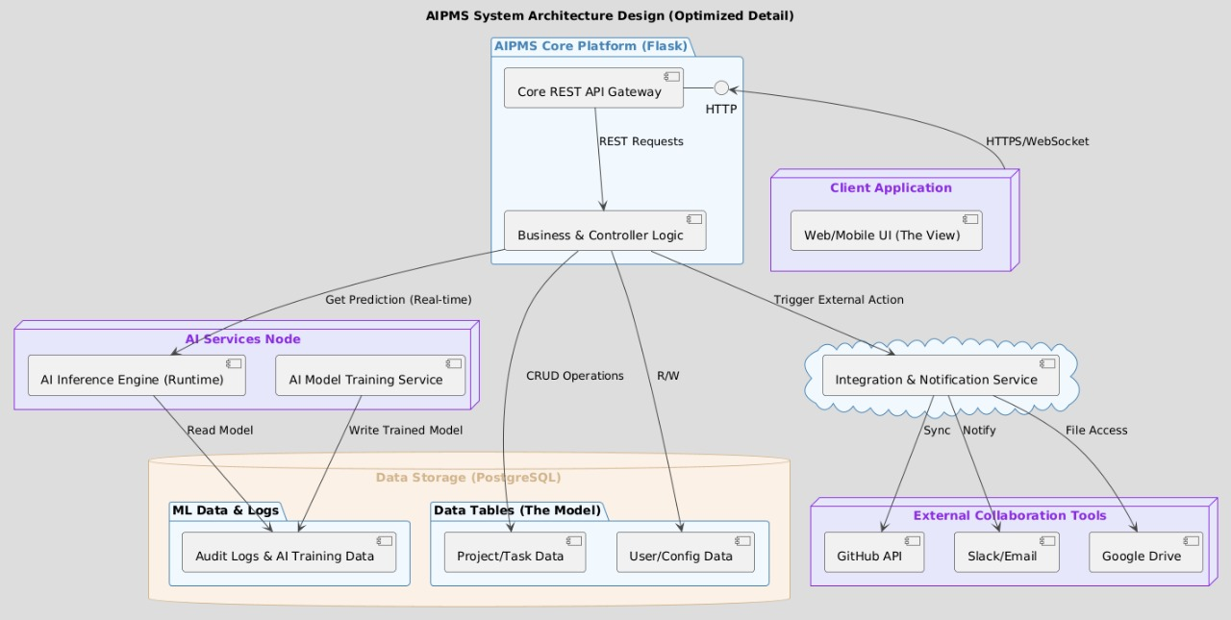
3.2 Discussion of Architectural Style and Components
The AIPMS project utilizes Monolithic Architecture that is logically segmented into five distinct layers. This approach was chosen to simplify deployment and manage complexity by clearly separating concerns into modular units that reside in a common hosting environment (Cloud/Server). The design ensures that the mandatory Model–View–Controller (MVC) pattern is rigidly enforced, with the Core Platform acting as the central Controller, the Client as the View, and the Data Storage as the Model/Persistence layer.
Domain/Layer | Component Name | MVC Role | Primary Responsibility
Client Application | [Web/Mobile UI] | View | Manages all user interface rendering, user interaction, and data presentation (dashboards, forms, task boards). Communicates exclusively via REST/WebSocket.
Core Platform | [Core REST API Gateway] | Controller (Interface) | The secure entry point for all client requests. Handles authentication, request validation, and routing to the core business logic.
Core Platform | [Business & Controller Logic] | Controller (Core) | Executes all core application business rules (task management, sprint logic, authorization). Orchestrates system flow, calling the AI, Integration, and Data layers.
AI Services Node | [AI Inference Engine (Runtime)] (AIE) | Logic/Service | Provides real-time, synchronous predictions and analysis (e.g., risk level, time estimates) to the Core Logic. Optimized for speed and low latency.
AI Services Node | [AI Model Training Service] (AMT) | Background Service | Runs asynchronous jobs to process historical data, update machine learning models, and persist the new models in the database.
External Integration | [Integration & Notification Service] (INT_SERVICE) | Service/Proxy | Acts as a central proxy to manage secure communication with all external APIs (GitHub, Slack, Drive). Handles data translation and manages notifications.
Data Storage | [Project/Task Data] & [User/Config Data] | Model (Transactional) | Stores all volatile, transactional application data (projects, tasks, user profiles). Accessed by the Core Logic for standard CRUD operations.
Data Storage | [Audit Logs & AI Training Data] | Model (Historical) | Stores historical activity logs and structured data used exclusively for training and validating the AI models.
3.3 Technology Stack and Tools
Frontend: HTML, CSS and JS
Backend: Python (Flask)
Database: PostgreSQL/MySQL/MongoDB
Cloud hosting: AWS/Azure/Docker
4. Detailed Design
4.1 Model–View–Controller (MVC) Design Pattern
4.1.1 Description of MVC
The Model-View-Controller (MVC) is an architectural pattern selected to separate the application logic from the user interface. This structure is critical for managing the complexity of AIPMS, which incorporates traditional project management with advanced Artificial Intelligence (AI) and multiple external integrations.
- Model: The business logic, data, state management, and the core data objects (e.g., Task, Project) reside here. It is independent of the user interface.
- View: Responsible for displaying the Model's data and capturing all user input (e.g., clicks, form submissions) .
- Controller: Acts as an intermediary, receiving user requests from the View, executing the appropriate logic in the Model, and selecting the next View to be rendered .
Reason for Choosing MVC: MVC was chosen to meet the non-functional requirements of scalability (for at least 10,000 users ) and maintainability. The separation of concerns ensures that the Flask (Python)-based application logic can be modified independently of the HTML5/CSS3/JavaScript frontend. This is essential for a system with mandatory AI components and frequent third-party API updates.
4.1.2 Mapping of Project Components to MVC
MVC Element | AIPMS Project Component(s) | Rationale
View | Client Application (Web/Mobile) [HTML5/JS UI] | Responsible for presenting data to the user and capturing user input. It is the end-user interface layer.
Controller | AIPMS Core Platform (Flask), Core REST API Gateway, Task & Sprint Business Logic, Auth & User Service, Reporting & Analytics Module | Handles all incoming requests from the client, interprets them, performs necessary data operations (via the Model), and selects the appropriate View response.
Model | PostgreSQL Database (Data Storage), AI Services Node (AI Inference Engine, AI Model Training Service) | Manages the application's data, state, business rules, and logic for data manipulation. It is unaware of the View or Controller.

4.1.3 Responsibilities of Model, View, and Controller
Each element within the MVC structure has distinct, single-purpose responsibilities:
Model (Data and Business Logic Management)
The Model layer is composed of the persistent data storage and the specialized AI processing services.
- Data Persistence and Retrieval: The PostgreSQL Database handles the storage, retrieval, and structural organization of all persistent data (User/Config Data, Project/Task Data, Audit Logs).
- State and Business Rules: It encapsulates the application’s state and enforces core business logic related to data integrity.
- AI Processing: The AI Services Node acts as a powerful Model extension, managing complex computational logic. It is responsible for training models, inferring predictions from new data (Prediction Interface/Inference Engine), and abstracting the complexity of the AI algorithms from the Controller.
View (User Interface)
The View is the entire Client Application (Web/Mobile), providing the visual and interactive element of the system.
- Presentation: It formats and presents the data retrieved from the Model (via the Controller) to the end-user, such as displaying sprint statuses, user roles, or prediction results.
- Input Capture: It captures all user interactions (clicks, form submissions, navigation) and forwards these actions directly to the Controller.
- Independence: Crucially, the View is designed to be stateless and passive, containing no business logic or direct knowledge of data structures, it only displays what the Controller instructs it to.

Controller (Request Handling and Orchestration)
The Controller is the AIPMS Core Platform (Flask), comprising the API Gateway and the internal business logic modules.
- Request Routing: The Core REST API Gateway receives HTTP and WebSocket requests from the Client and routes them to the appropriate service (e.g., Auth, Task Logic).
- Action Execution: Modules like Task & Sprint Business Logic receive the request, determine what needs to be done, and interact with the Model layer (database or AI Services) to fulfill the request.
- Response Generation: After the Model updates or returns data, the Controller processes this information and sends an appropriate response back to the View for rendering (e.g., success message, updated data payload, or error).
4.1.4 Interaction Between Components
The components interact in a specific, cyclical manner to maintain the separation of concerns. This flow defines how user actions are processed and how the application state is managed.
The cycle begins:
- User Interaction (View Controller): The user interacts with the View (Client Application), initiating an action (e.g., creating a task, requesting a prediction). The View captures this input and sends a request (via HTTP/REST) to the Controller (Core REST API Gateway).
- Request Handling (Controller): The Controller receives the request and, after authentication (Auth & User Service), determines the required business operation.
- Data/Logic Access (Controller Model): The Controller calls upon the Model layer for data or processing.
    - For saving/retrieving data, it interacts with the PostgreSQL Database.
    - For complex computation, it calls services within the AI Services Node.
- State Update (Model): The Model performs the operation (e.g., runs a query, trains a model, calculates a prediction) and updates its internal state. The Model does not notify the View directly.
- View Update (Controller View): The Controller receives the result from the Model. It packages this data into a digestible JSON format and sends it back to the View. The View then uses this new data to update the user interface, completing the cycle.

4.2 UML Diagrams
4.2.2 Detailed Class Diagram
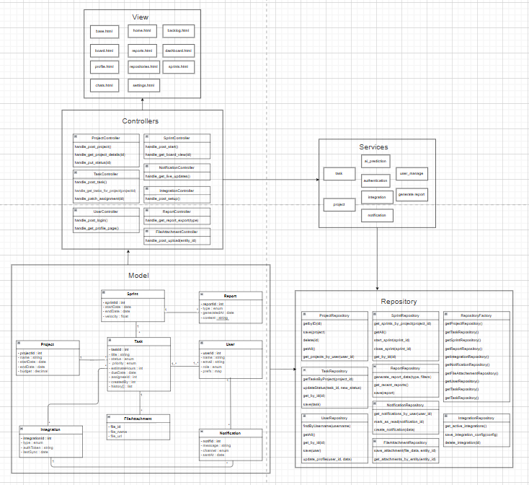
1. User
Description:
Represents any individual who interacts with the system (team member, project manager, or admin). Users are responsible for creating, assigning, and tracking tasks. Each user receives notifications and may integrate their workspace with external tools.
Attributes:
- userID : int — Unique identifier for each user.
- name : string — Full name of the user.
- email : string — User’s registered email address.
- role : string — Defines the access level (Admin, Developer, Manager, Viewer).

Methods:
- createTask() — Creates a new task under a project or sprint.
- assignTask() — Assigns a task to a team member.
- viewReport() — Views project reports.
- receiveNotification() — Handles system or integration notifications.
Relationships:
- 1..* association with Task (a user can create/own many tasks).
- 1 association with Notification (user receives notifications).
- 1..* association with Project (user participates in multiple projects).
2. Task
Description:
Represents the fundamental unit of work within a project or sprint. Tasks can be created, updated, and tracked, with AI predicting deadlines and priority adjustments.
Attributes:
- taskID : int — Unique identifier of the task.
- title : string — Short description of the task.
- description : string — Detailed information about the task.
- status : string — Task state (e.g., To Do, In Progress, Done).
- deadline : date — AI-predicted or user-defined completion date.
Methods:
- updateStatus() — Updates the current task status.
- attachFile() — Links a file or document to the task.
- linkIntegration() — Syncs related GitHub commits or external data.
Relationships:
- 1..* association with User (each task is created or assigned to one or more users).
- 1 composition with Sprint (a sprint contains multiple tasks).
- 1 aggregation with FileAttachment (a task can have attached files).
- 1 association with AI Engine (AI predicts deadlines and adjusts schedules).
3. Sprint
Description:
A defined time-boxed iteration in a project. It organizes multiple tasks and reports progress. AI models analyze velocity, predict completion, and suggest adjustments.
Attributes:
- sprintID : int — Unique sprint identifier.
- startDate : date — Sprint start date.
- endDate : date — Sprint end date.
- velocity : float — Speed of task completion based on past data.
Methods:
- addTask() — Includes a task in the sprint.
- generateSprintReport() — Produces a sprint progress report.
Relationships:
- 1..* composition with Task (each sprint contains many tasks).
- 1 association with Project (belongs to one project).
- 1 association with Report (each sprint generates reports).
- 1 association with AI Engine (AI adjusts sprint scope and duration).

4. Project
Description:
Represents a complete project in the system. Each project includes multiple sprints, tasks, and associated users.
Attributes:
- projectID : int — Unique identifier for each project.
- name : string — Project name.
- description : string — Summary of the project scope and goals.
- startDate : date — Project start date.
- endDate : date — Project completion date.
Methods:
- createSprint() — Starts a new sprint for the project.
- addMember() — Adds users to the project.
- generateProjectReport() — Compiles all reports related to this project.
Relationships:
- 1..* composition with Sprint (a project has one or more sprints).
- 1..* association with User (many users work on a project).
- 1 association with Report (reports summarize project performance).
5. Report
Description:
Provides visual and textual summaries of project or sprint performance. It can include AI analytics, risk assessments, and velocity trends.
Attributes:
- reportID : int — Unique identifier of the report.
- type : string — Report type (e.g., sprint, project, AI analysis).
- date : date — Date of report generation.
- content : string — Summary and analytics details.
Methods:
- generateReport() — Creates a report automatically.
- exportReport() — Exports reports as PDF or Excel files.
Relationships:
- 1 association with Sprint (each sprint generates one or more reports).
- 1 association with Project (summary reports per project).
6. AI Engine
Description:
Acts as the system’s intelligence core, analyzing historical data, predicting deadlines, estimating workloads, and detecting potential risks.
Attributes:
- modelVersion : string — Version of the AI model.
- lastTrained : date — Date the model was last trained.

Methods:
- predictDeadline() — Predicts task completion times.
- forecastVelocity() — Forecasts sprint completion trends.
- analyzeRisk() — Detects risks based on communication and data patterns.
Relationships:
- 1..* association with Sprint and Task (analyzes both).
- 1 association with Project (provides project-level insights).
7. Integration
Description:
Handles system connections with third-party services such as GitHub, Google Drive, Slack, and Email for data syncing and communication.
Attributes:
- integrationID : int — Unique integration record.
- serviceName : string — Name of the connected service.
- apiKey : string — Authentication key for the integration.
Methods:
- syncData() — Syncs commits, messages, or files.
- fetchData() — Retrieves information from integrated platforms.
Relationships:
- 1..* association with FileAttachment (Google Drive).
- 1..* association with Task (GitHub sync).
- 1..* association with Notification (Slack/Email updates).

8. FileAttachment
Description:
Represents any file uploaded or linked to a task (documents, reports, screenshots).
Attributes:
- fileID : int — Unique identifier.
- fileName : string — File name.
- fileURL : string — Cloud or local storage link.
Methods:
- uploadFile() — Uploads a file to the system.
- shareFile() — Shares the file with other team members.
Relationships:
- 1 aggregation with Task (a task may have many attached files).
- 1 association with Integration (Google Drive or other services).
9. Notification
Description:
Handles system alerts, task reminders, and integration updates. Notifications are sent to users via connected communication channels.
Attributes:
- notificationID : int — Unique notification ID.
- channel : string — Slack, Email, or in-app.
- message : string — Notification content.
- timestamp : datetime — Time sent.

Methods:
- sendNotification() — Delivers the notification.
- markAsRead() — Marks it as viewed by the user.
Relationships:
- 1..* association with User (users receive notifications).
- 1 dependency with Integration (uses third-party channels).

4.2.3 Sequence Diagrams
First: Authentication:
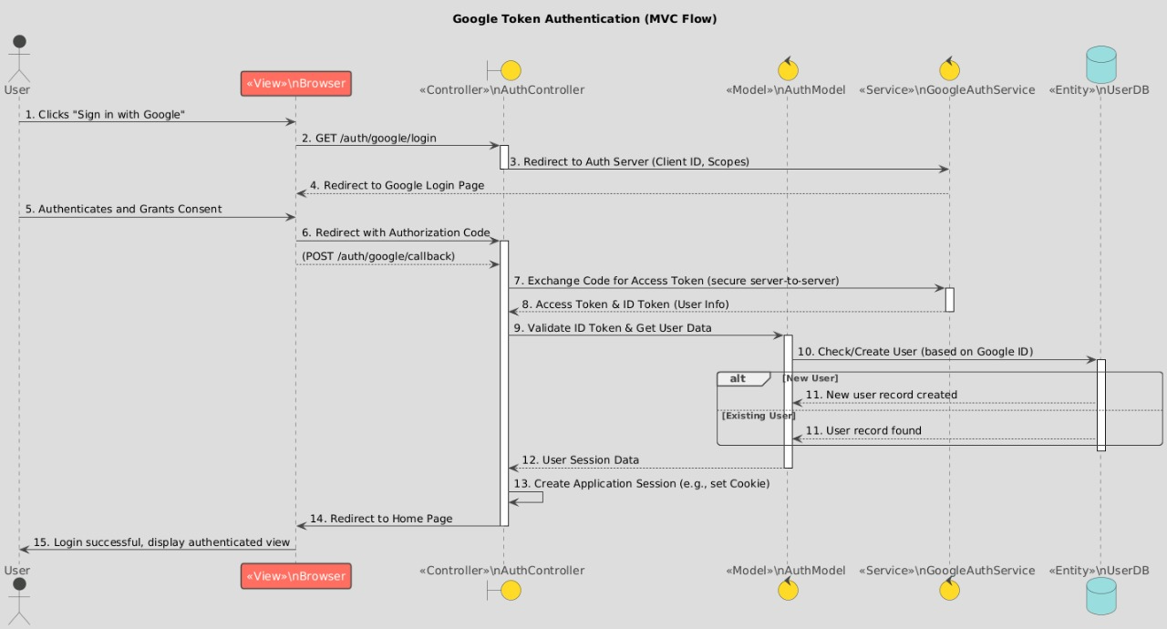
The process begins when the User clicks "Sign in with Google" (Step 1). The InAuthController handles the request (Step 2) and redirects the user to the Google Login Page on the Auth Server (Step 3). After the user authenticates and grants consent (Step 5), the Auth Server redirects back with an Authorization Code (Step 6). The InAuthService then securely exchanges this code for an Access Token and ID Token (Steps 7 & 8) and validates the ID Token to get user data (Step 9). The InAuthModel checks if the user exists in the InUserDB (Step 10). New users have a record created (Step 11), while existing users are found (Step 11). Finally, the InAuthController creates a User Session and Application Session (Steps 12 & 13), redirects to the Home Page (Step 14), and the user sees the login successful, authenticated view (Step 15).

Second: Task creation, editing, and assignment:
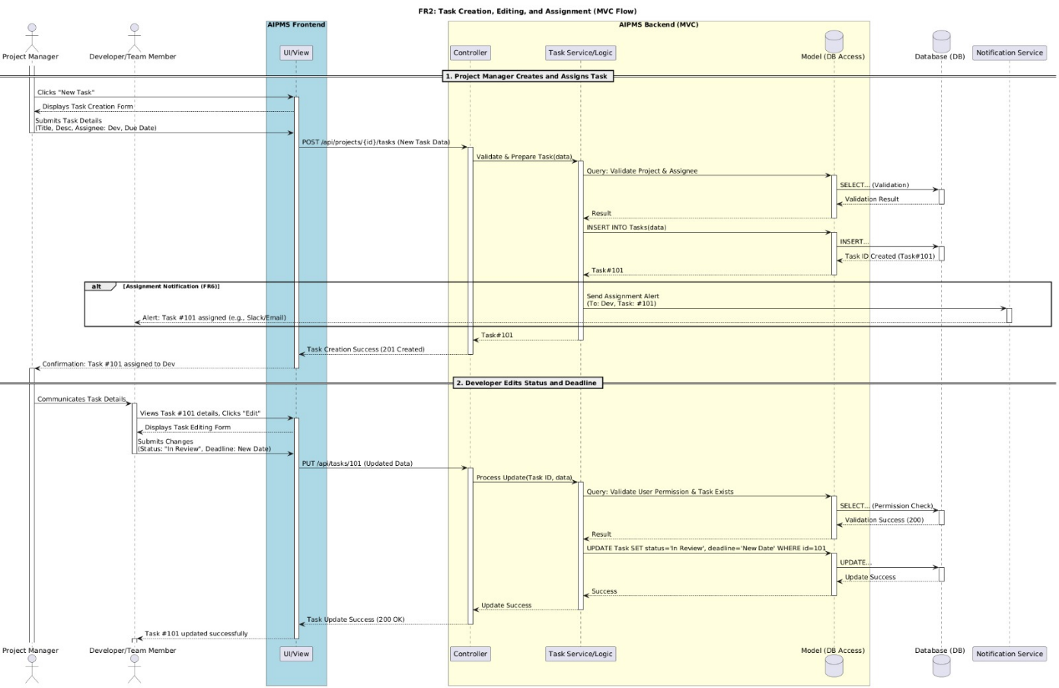
In the creation phase, the Project Manager submits a new task via a Frontend POST request, which the Backend's Controller and Task Service/Logic validate and then process by executing an INSERT query in the Database (DB); critically, a Notification Service is then triggered to send an assignment alert to the Developer/Team Member before the Frontend confirms the task's successful creation. In the subsequent editing phase, the Developer submits an update (like changing the status or deadline) via a PUT request; the Task Service verifies the user's permission and task existence against the DB, executes an UPDATE query, and upon success, the Frontend confirms the change, illustrating a clear, secure, and sequential separation of concerns among the system components.

Third: Project manager
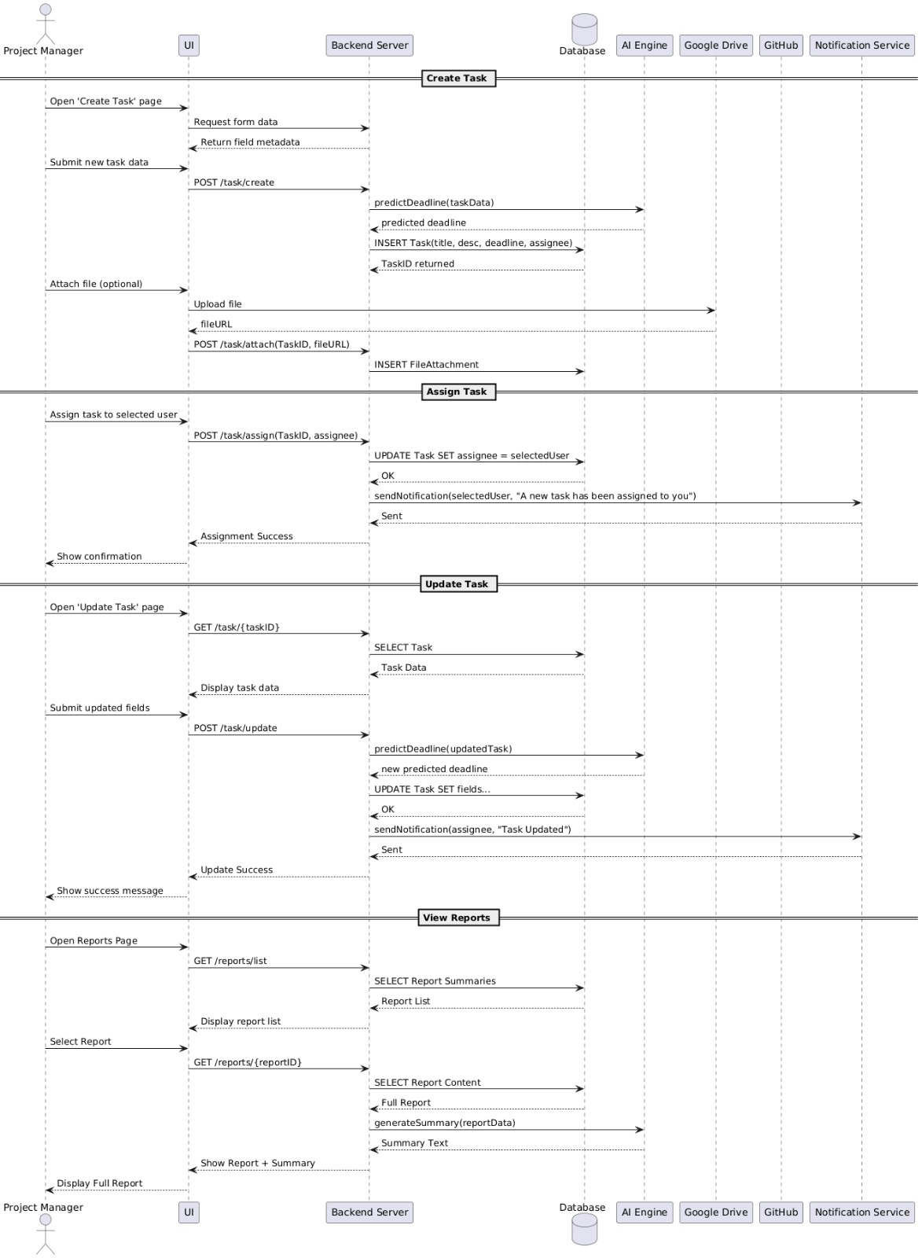

The Project Manager initiates Task Creation by submitting data to the Backend Server, which leverages the AI Engine to predict a deadline before performing an INSERT into the Database and handling optional file attachments; subsequently, Task Assignment involves an UPDATE query and immediately triggers the Notification Service to alert the assignee. For Task Updating, the Backend Server first fetches current data via GET, and upon submission of new fields via POST, again consults the AI Engine for a new deadline before performing an UPDATE and sending another notification. Finally, the View Reports flow involves the UI sending GET requests to the Backend Server, which queries the Database for summary and full report content before displaying the results to the Project Manager, showcasing a robust, integrated, and service-oriented system design.

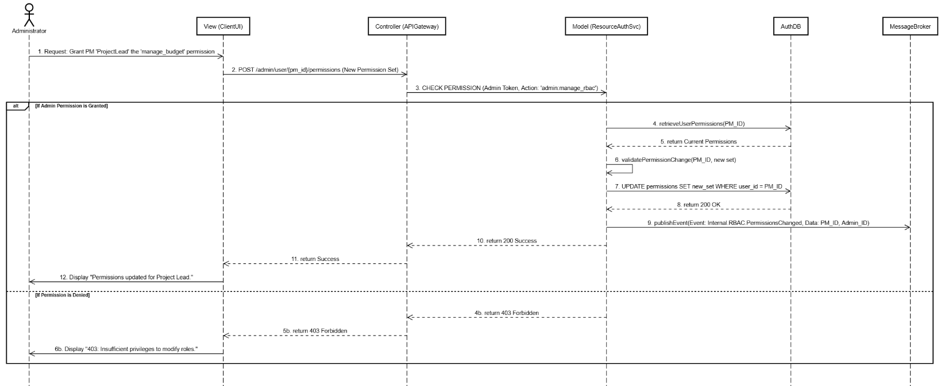
Fourth: Administrator
This sequence diagram illustrates the workflow for an Administrator granting a new permission set to a Project Manager (PM), emphasizing permission checks and event-driven updates in a secure RBAC (Role-Based Access Control) system. The process begins with the Administrator requesting the permission change via the View (ClientUI), which sends a POST request to the Controller (APIGateway). The Controller's first action is to request the Model (ResourceAuthSvc) to CHECK_PERMISSION for the Administrator to perform the admin:manage_rbac action. If the permission is denied, the system immediately returns a 403 Forbidden error. If permission is granted, the ResourceAuthSvc retrieves the PM's Current Permissions from the AuthDB, validates the New Permission Set, and executes an UPDATE query in the AuthDB to apply the changes. Finally, the ResourceAuthSvc publishes an internal RBACPermissionChanged Event to the MessageBroker to notify other services of the change, before returning a 200 Success to the Controller, which is then relayed to the View to confirm to the Administrator that the Permissions updated for ProjectLoad.

Fifth: Integrations:
GitHub:
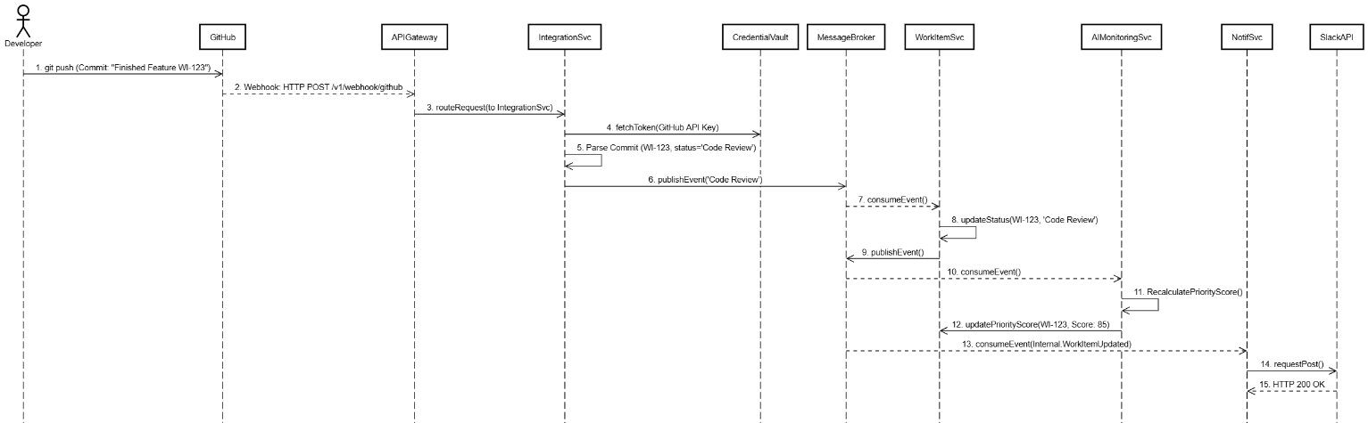
The sequence diagram details an automated Microservice Flow triggered by a Developer Git Push to GitHub, illustrating how a commit mentioning a specific work item (e.g., "WI-123") drives status updates and priority recalculation asynchronously. This process begins with GitHub sending a Webhook to the APIGateway, which routes it to the IntegrationSvc; this service authenticates, parses the commit to determine the new status (e.g., "Code Review"), and publishes an event to the MessageBroker. The WorkItemSvc consumes this event to update the work item's status, and subsequently, the AAMonitoringSvc consumes the resulting update event to recalculate the Priority Score, also updating the work item. Finally, the NotifSvc consumes a final internal update event to push a notification via the SlackAPI, completing the distributed, event-driven workflow and confirming the successful webhook handling with an HTTP 200 OK response.
Google drive:
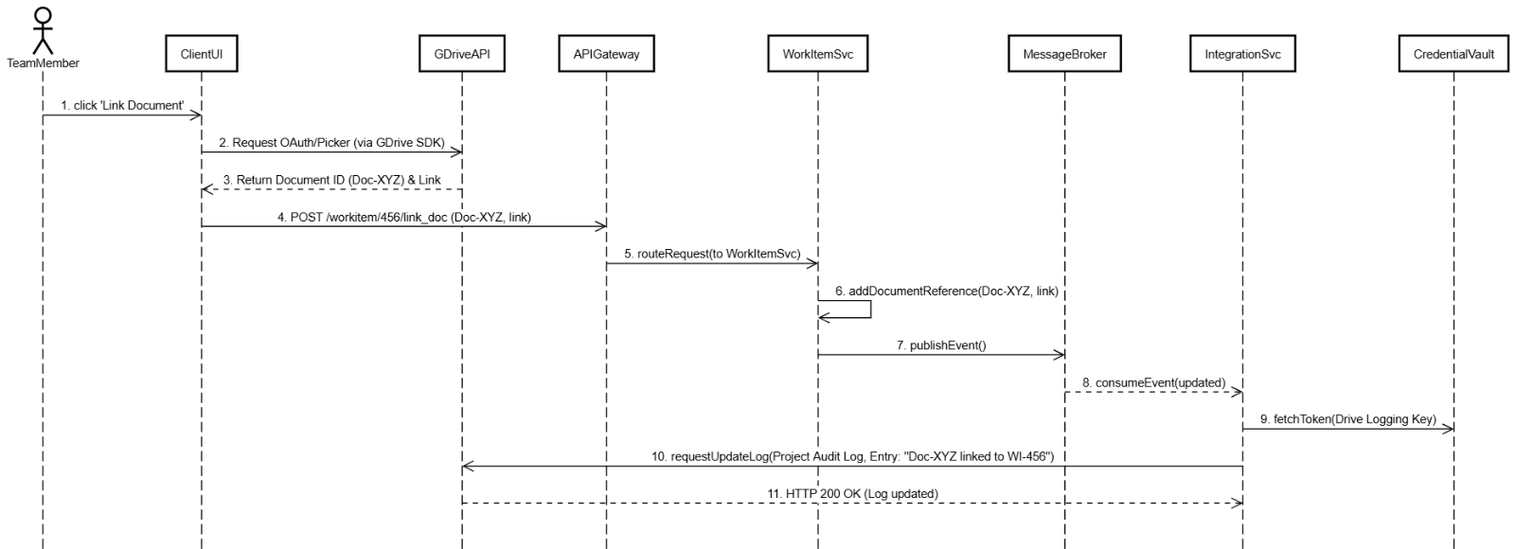
The sequence diagram details a Document Linking Workflow where a Team Member initiates the process from the ClientUI by using the GDriveAPI SDK to select a document, which returns the Document ID and Link. This information is submitted via a POST request through the APIGateway to the WorkItemSvc, which securely adds the document reference to the relevant work item (WI-456). To ensure auditability, the WorkItemSvc then publishes an event to the MessageBroker, which the IntegrationSvc consumes; the IntegrationSvc fetches the necessary Drive Logging Key from the CredentialVault to authorize a request back to the GDriveAPI to update the Project Audit Log entry, thus separating the core business logic (Work Item Update) from the auxiliary task (Audit Logging) before the system confirms the overall process completion with an HTTP 200 OK response.
4.3 UI/UX Design
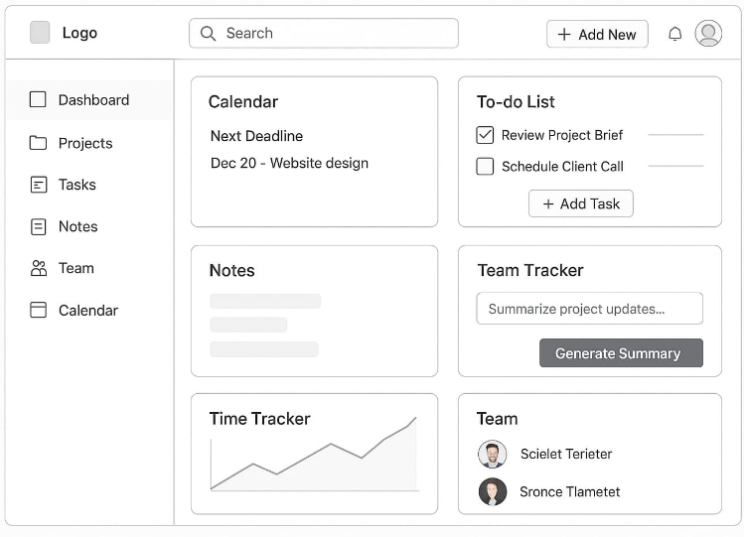
4.3.1 Wireframes / Mockups
1. Home and Dashboard
There is a main navigation bar on the left side of the page with all the pages. The Home page is a quick summary of all your personal and team activities when you first open the app. It uses different boxes to show key information. It includes a Calendar to display the next important deadline, a simple To-do List for immediate tasks, and areas for Notes and a Time Tracker that shows a progress chart. A tool called Team Tracker is included to summarize team updates. It also lists your team members. This page is designed to give you all the important information you need very quickly.
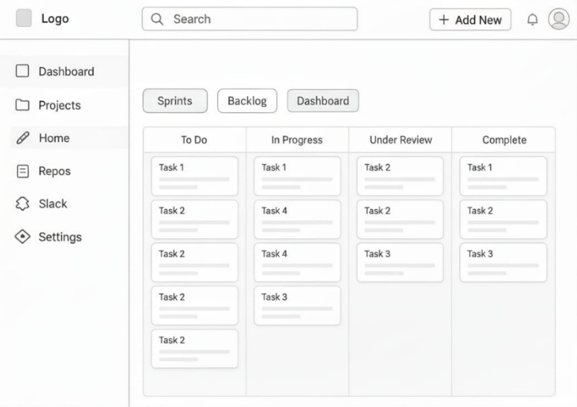
2. Board page
The page is a task board that helps teams manage their projects. It's like a whiteboard where you track tasks. You can easily switch views between different work cycles (Sprints), the list of future tasks (Backlog), and the main Dashboard. The board is divided into columns representing the task status: To Do, In Progress, Under Review, and Complete. Tasks are shown as movable cards. This page is the main place to see what everyone is working on and where each task stands.
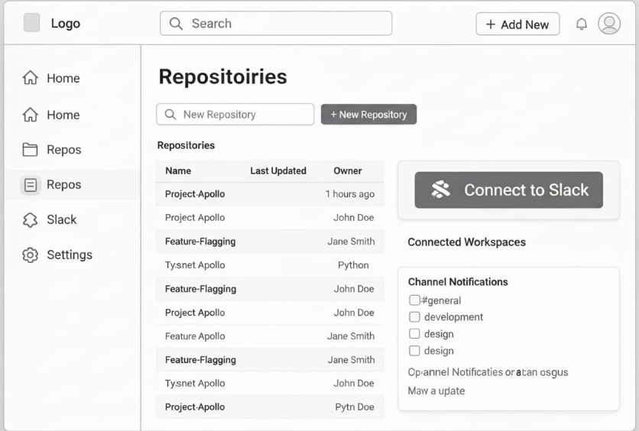
3. Repositories Management
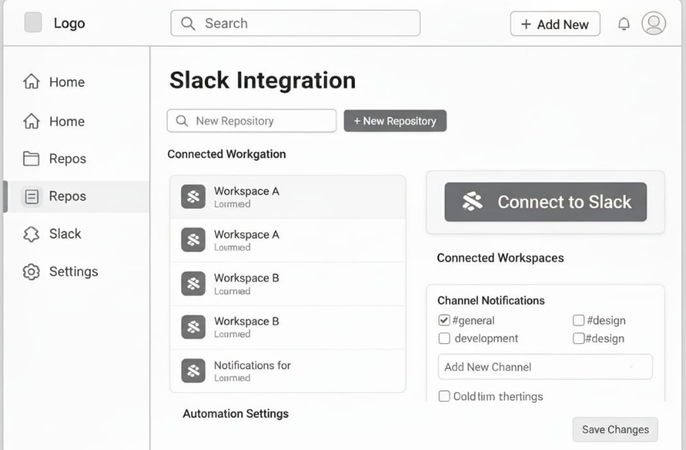
The repositories management page is for managing your code storage areas, called Repositories. It lists all your code projects by their Name, when they were Last Updated, and who the Owner is. You can search for projects or create a new one. A key feature is connecting this code storage to Slack, a chat program. On the right, you can choose which chat channels (like #general) should automatically get alerts and updates about changes to your code projects.
4. Slack Integration
The slack page lets you control how the app connects to Slack, the team chat platform. It lists all the different Slack team spaces (Workspaces) that are linked to the app. The main job of this page is to manage Channel Notifications. This means you can choose exactly which chat rooms (channels) will get automatic messages from the app.

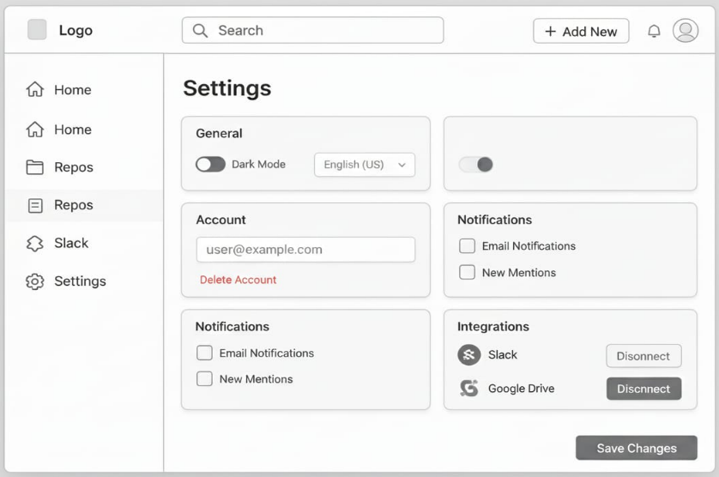
  - General Settings
This page holds all the main controls for the application. In the General section, you can switch to Dark Mode and select the app's Language. The Account section shows your email and has a button to Delete Account. The Integrations section shows and lets you unlink connected services, such as Slack and Google Drive. Other boxes let you turn on or off alerts sent by Email Notifications or notifications for New Mentions (when someone names you).

4.4 Data Design
4.4.1 Database Schema / ER Diagram
Entity Relationship (ER) Diagram:
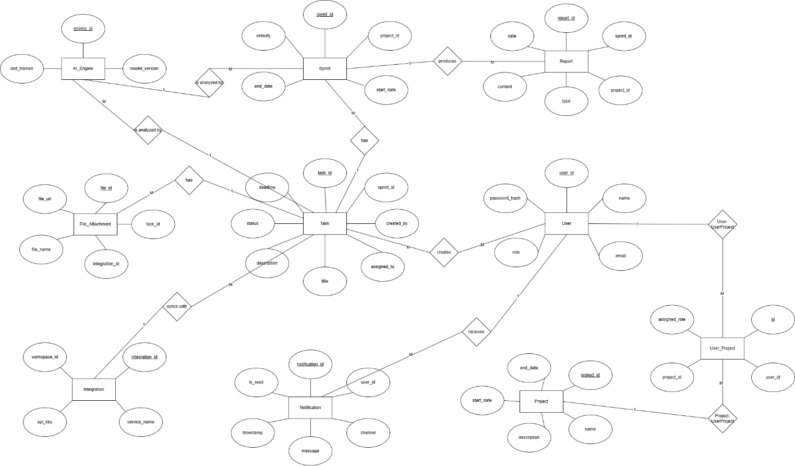

The system is built around core entities: Project, which defines the overall scope and timeframe; Sprint, representing time-boxed iterations within a project; and Task, the smallest unit of work, linked directly to a sprint. Personnel are managed through the User entity, with a many-to-many relationship to projects tracked by the User_Project junction table, and tasks assigned to individual users via the assigned_to attribute. Supporting administrative and analytical functions include Reports, which summarize data from sprints and projects, and File_Attachments, which store metadata for documents linked to tasks. Advanced components involve the AI_Engine, which tracks model versioning and training dates related to sprint data, and the Integration entity, which manages external service connections. Finally, the Notification entity ensures users receive system alerts and messages.

Schema:
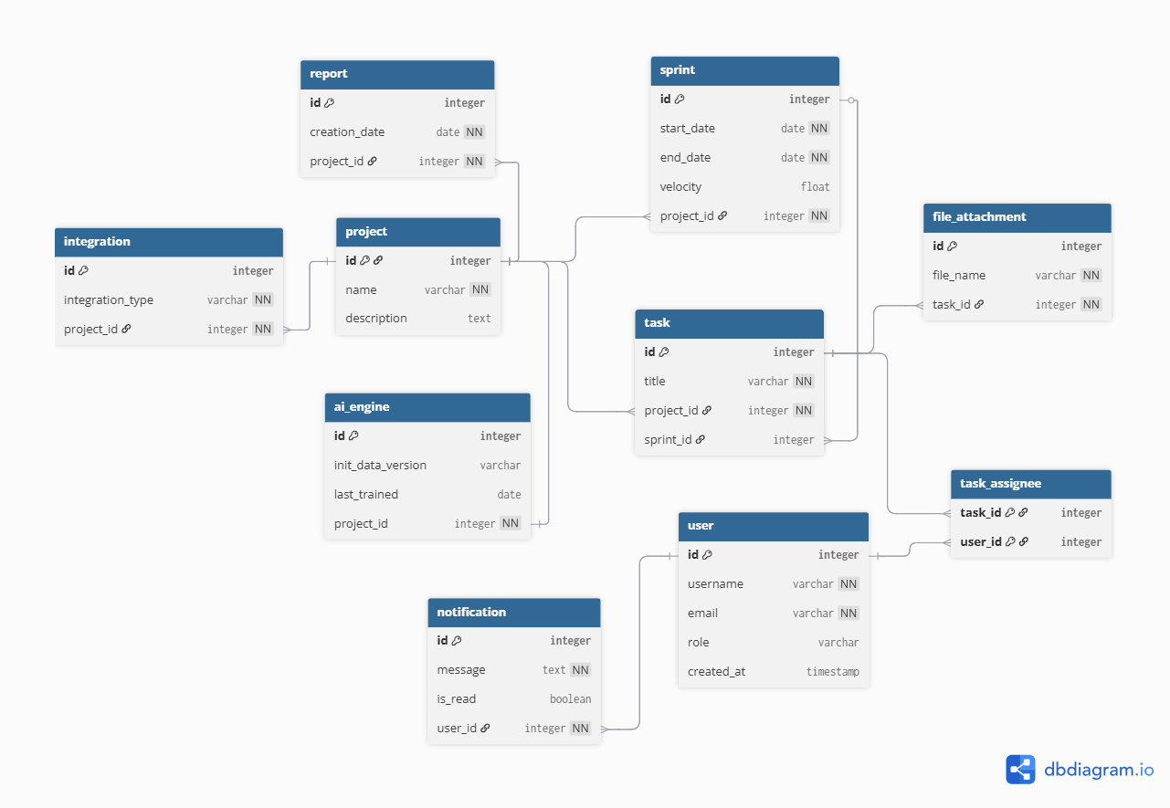
The system is organized around core entities like project, sprint, and task. A project serves as the highest-level container, containing multiple iterative sprints, which in turn group individual tasks. The schema includes a user entity to represent team members, with the task_assignee junction table handling the many-to-many relationship where multiple users can be assigned to multiple tasks. Supporting features include file_attachment for tasks, report generation, and external integration configuration, all linked back to the parent project. Additionally, it includes tables for specialized functionality, such as ai_engine configuration tied to a project and a notification system linked directly to a specific user.

4.4.3 Data Dictionary
1. project
The central entity representing a defined scope of work.
Column/Field | Data Type | Constraint | Purpose
id | Integer | PK | Unique identifier for the project.
name | Varchar | NN | The title or name of the project.
description | Text |  | A detailed explanation of the project's goals and scope.

2. user
Represents an individual user, team member, or employee in the system.
Column/Field | Data Type | Constraint | Purpose
id | Integer | PK | Unique identifier for the user.
username | Varchar | NN | The unique login name for the user.
email | Varchar | NN | The user's email address.
role | Varchar |  | The role of the user (e.g., 'Developer', 'Manager', 'Admin').
created_at | Timestamp |  | Date and time the user account was created.

3. sprint
Represents an iteration or fixed time period of work within a project.
Column/Field | Data Type | Constraint | Purpose
id | Integer | PK | Unique identifier for the sprint.
start_date | Date | NN | The date the sprint began.
end_date | Date | NN | The date the sprint is scheduled to end.
velocity | Float |  | A metric representing the capacity or rate of work completion.
project_id | Integer | FK, NN | Links the sprint to its parent project.

4. task
Represents a singular item of work to be completed.
Column/Field | Data Type | Constraint | Purpose
id | Integer | PK | Unique identifier for the task.
title | Varchar | NN | The brief title or summary of the task.
project_id | Integer | FK, NN | Links the task to the project it belongs to.
sprint_id | Integer | FK | Links the task to the specific sprint it is scheduled for.

5. task_assignee
A junction table defining which users are assigned to which tasks (many-to-many relationship).
Column/Field | Data Type | Constraint | Purpose
task_id | Integer | FK | Links the assignment to a specific task.
user_id | Integer | FK | Links the assignment to a specific user.

6. file_attachment
Stores metadata for files uploaded and associated with a task.
Column/Field | Data Type | Constraint | Purpose
id | Integer | PK | Unique identifier for the attachment record.
file_name | Varchar | NN | The name of the attached file.
task_id | Integer | FK, NN | Links the attachment to its associated task.

7. report
Stores records of generated reports related to a project.
Column/Field | Data Type | Constraint | Purpose
id | Integer | PK | Unique identifier for the report.
creation_date | Date | NN | The date the report was generated.
project_id | Integer | FK, NN | Links the report to the project it covers.

8. notification
Stores system messages or alerts intended for a specific user.
Column/Field | Data Type | Constraint | Purpose
id | Integer | PK | Unique identifier for the notification.
message | Text | NN | The content of the notification.
is_read | Boolean |  | Flag to indicate if the user has viewed the notification.
user_id | Integer | FK, NN | Links the notification to the receiving user.

9. integration
Stores configurations for external services or tools linked to a project.
Column/Field | Data Type | Constraint | Purpose
id | Integer | PK | Unique identifier for the integration configuration.
integration_type | Varchar | NN | The type of external service being integrated (e.g., 'GitHub', 'Jira').
project_id | Integer | FK, NN | Links the integration to the project it serves.

10. ai_engine
Stores configuration or status details for an AI or machine learning component associated with a project.
Column/Field | Data Type | Constraint | Purpose
id | Integer | PK | Unique identifier for the AI engine configuration.
init_data_version | Varchar |  | The version of the initial training data used for the model.
last_trained | Date |  | The date the AI model was last trained or updated.
project_id | Integer | FK, NN | Links the AI configuration to its specific project.

5. Conclusion
5.1 Summary of Design Phase
The Design Phase Document (DPD) for the All-in-one AI Project Management System (AIPMS) successfully translated the comprehensive requirements from the Software Requirements Specification (SRS) into a detailed, executable technical blueprint, providing the necessary foundation for the Implementation phase.
The system employs a logically segmented Monolithic Architecture to simplify deployment while managing the complexity of integrated AI and external services. This design centers around the AIPMS Core Platform (Flask), which acts as the central Controller orchestrating the flow between the Client Application (View) and the Data Storage (Model). Specialized services, such as the AI Services Node and Integration & Notification Service, manage complex, non-transactional workloads independently. The confirmed technology stack relies on Python (Flask) for backend logic, PostgreSQL for transactional data, and MongoDB for ML/Log data, ensuring the system can handle its high scalability goal (10,000 users) while adhering to mandatory constraints like GDPR compliance and the use of TensorFlow/PyTorch for AI modeling.
To ensure maintainability and the separation of concerns, the Model-View-Controller (MVC) pattern governs the application logic. The Client Application (Web/Mobile UI) functions as the View; the AIPMS Core Platform (Flask) acts as the Controller handling request routing and orchestration; and the Model is composed of the Data Storage and AI Services Node, managing state, business rules, and complex predictive processing. This design is validated through detailed Sequence Diagrams that illustrate critical flows, including Google Token Authentication, core Task Management, Administrator RBAC control, and complex, event-driven integrations. Integration sequences clearly model how external events (like a GitHub commit) trigger internal AI recalculations and update notifications across communication channels (Slack).
This phase produced several critical technical artifacts, including the System Architecture Diagram and a Detailed Class Diagram defining the primary domain entities (User, Task, Project). Five detailed Sequence Diagrams were created to model critical flows, including the Administrator's Role-Based Access Control (RBAC) Management and intricate external integrations. Finally, UI/UX Wireframes provide visual specifications for the main dashboard and feature management screens. This DPD serves as the final, approved technical specification, clearing the path for the immediate commencement of the Implementation Phase.

